**TCP Nat Traversal/ Hole Punching**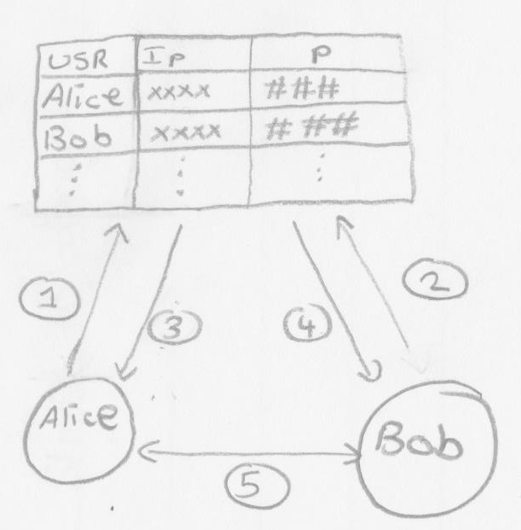

1. **Alice joins the network (1) by creating connection to a mediator. When this happens, Alice's NAT creates a mapping from her public ip to her local ip.**
2. **The mediator server receives the connection and store Alice's public ip:port in the directory**
3. **Bob does the same (2), Joins the network and publishes his ip:port in the mediator**
4. **Alice wants to communicate with bob. So she looks up Bob's ip:port from the directory (mediator). (3)**
5. **Alice sends data on Bob's ip:port which she got from the server. (5)**
6. **Since Bob also has a mapping from his public ip:port to his local ip:port, the NAT simply forwards any data received on Bob's public ip:port to his computer.**
7. **Same works for Alice**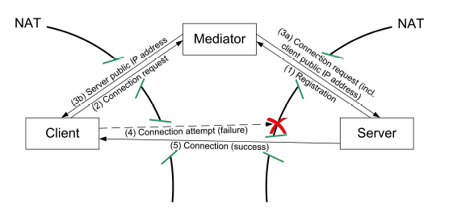

One problem is that the NAT mappings in Alice's NAT server will time out, either after a fixed time, or after a period of inactivity.

A second potential problem is that the NAT server could make the restriction that Alice's NAT mapping is only "good" for TCP connections established by Alice, or connections between Alice and the initial IP "she" connected to. (In other words, direct communication between Alice & Bob may be blocked.)